**REST - Country Web Service**

**/spring-learn/src/main/resources/country.xml**

<?xml version=*"1.0"* encoding=*"UTF-8"*?>

<beans xmlns=*"http://www.springframework.org/schema/beans"*

xmlns:xsi=*"http://www.w3.org/2001/XMLSchema-instance"*

xsi:schemaLocation=*"http://www.springframework.org/schema/beans*

*https://www.springframework.org/schema/beans/spring-beans.xsd"*>

<bean id=*"in"* class=*"com.cognizant.spring_learn.Country"*>

<property name=*"code"* value=*"IN"* />

<property name=*"name"* value=*"India"* />

</bean>

<bean id=*"us"* class=*"com.cognizant.spring_learn.Country"*>

<property name=*"code"* value=*"US"* />

<property name=*"name"* value=*"United States"* />

</bean>

<bean id=*"de"* class=*"com.cognizant.spring_learn.Country"*>

<property name=*"code"* value=*"DE"* />

<property name=*"name"* value=*"Germany"* />

</bean>

<bean id=*"jp"* class=*"com.cognizant.spring_learn.Country"*>

<property name=*"code"* value=*"JP"* />

<property name=*"name"* value=*"Japan"* />

</bean>

<bean id=*"countryList"* class=*"java.util.ArrayList"*>

<constructor-arg>

<list>

<ref bean=*"in"*></ref>

<ref bean=*"us"*></ref>

<ref bean=*"de"*></ref>

<ref bean=*"jp"*></ref>

</list>

</constructor-arg>

</bean>

</beans>

**/spring-learn/src/main/java/com/cognizant/spring_learn/Country.java**

**package** com.cognizant.spring_learn;

**import** org.slf4j.Logger;

**import** org.slf4j.LoggerFactory;

**public** **class** Country{

**private** String code;

**private** String name;

**private** **static** **final** Logger ***LOGGER*** = LoggerFactory.*getLogger*(Country.**class**);

**public** Country(){

***LOGGER***.debug("Inside Country Constructor");

}

**public** String getCode() {

***LOGGER***.debug("Inside getCode");

**return** code;

}

**public** **void** setCode(String code) {

***LOGGER***.debug("Inside setCode");

**this**.code = code;

}

**public** String getName() {

***LOGGER***.debug("Inside getName");

**return** name;

}

**public** **void** setName(String name) {

***LOGGER***.debug("Inside setName");

**this**.name = name;

}

@Override

**public** String toString() {

**return** "[Name: " + name + "; Code: " + code + "]";

}

}

**/spring-learn/src/main/java/com/cognizant/spring_learn/controller/CountryController.java**

**package** com.cognizant.spring_learn.controller;

**import** org.slf4j.Logger;

**import** org.slf4j.LoggerFactory;

**import** org.springframework.context.ApplicationContext;

**import** org.springframework.context.support.ClassPathXmlApplicationContext;

**import** org.springframework.web.bind.annotation.RequestMapping;

**import** org.springframework.web.bind.annotation.RestController;

**import** com.cognizant.spring_learn.Country;

@RestController

**public** **class** CountryController {

**private** **static** **final** Logger ***LOGGER*** = LoggerFactory.*getLogger*(CountryController.**class**);

@RequestMapping("/country")

**public** Country getCountryIndia() {

***LOGGER***.info("Start getCountryIndia");

ApplicationContext context = **new** ClassPathXmlApplicationContext("country.xml");

Country country = (Country) context.getBean("in", Country.**class**);

***LOGGER***.debug("Country: {}", country);

***LOGGER***.info("End getCountryIndia");

**return** country;

}

}

**Output** (Logs)

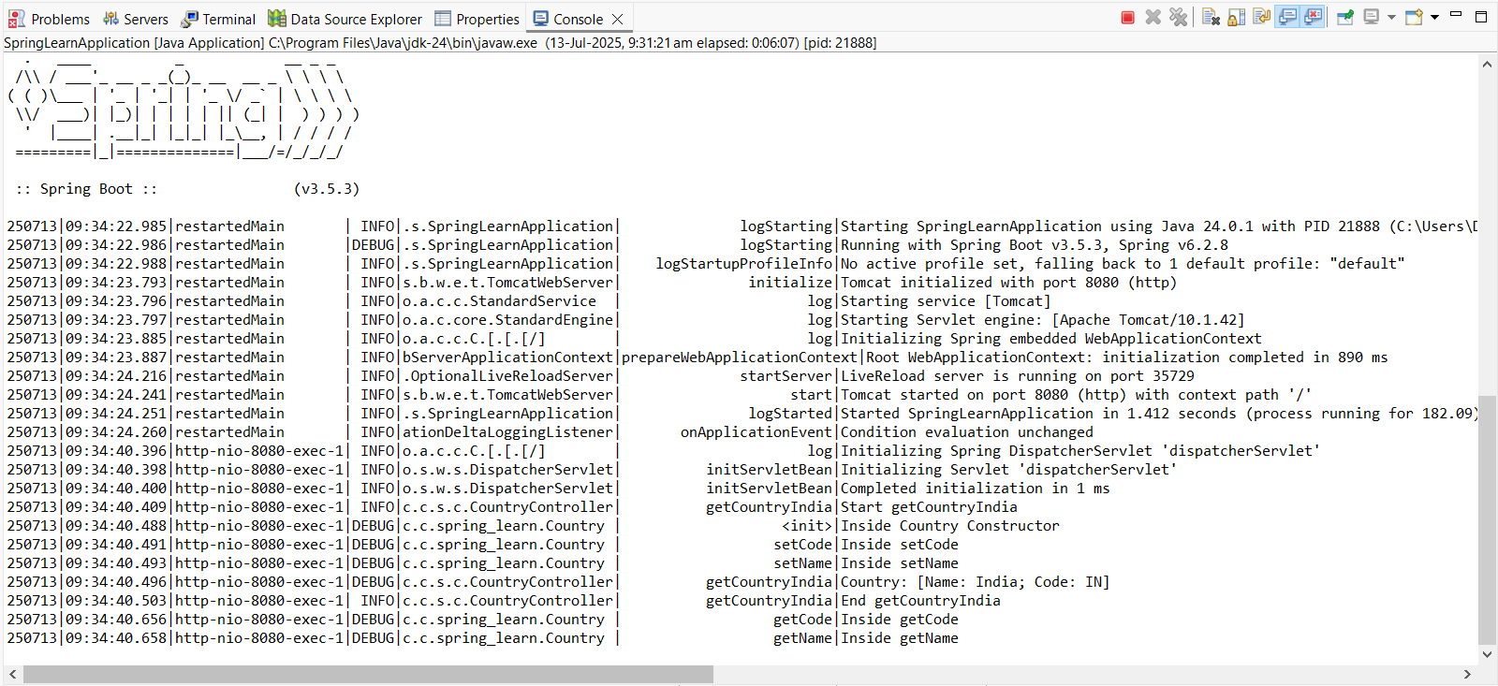

**Output** (Chrome browser)

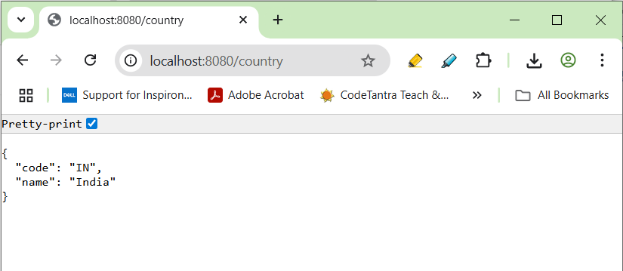

**Output** (Postman)

